Month 2: Week 2 Report
• Simulate attacks: TCP port scan, SSH brute force
• Verify alerts for custom rules
• Analyze detection quality
Introduction
1. Simulate TCP Port Scan
In Week 2, practical attack scenarios were simulated to test Snort’s detection capabilities. TCP SYN port scanning and SSH brute force attacks were performed on the monitored system. The purpose was to verify if the custom rules created in Week 1 were triggered correctly and to analyze the accuracy and quality of Snort’s alerts.

Simulate Attacks
  - Port scanning is used by attackers to find open ports.
  - Tools used: Nmap and Hping3.
  - Port scan sends multiple SYN packets to detect services.
  - Snort should detect this using the custom SYN scan rule.
  - The objective is to test Rule ID: 1000002 (SYN Port Scan rule).

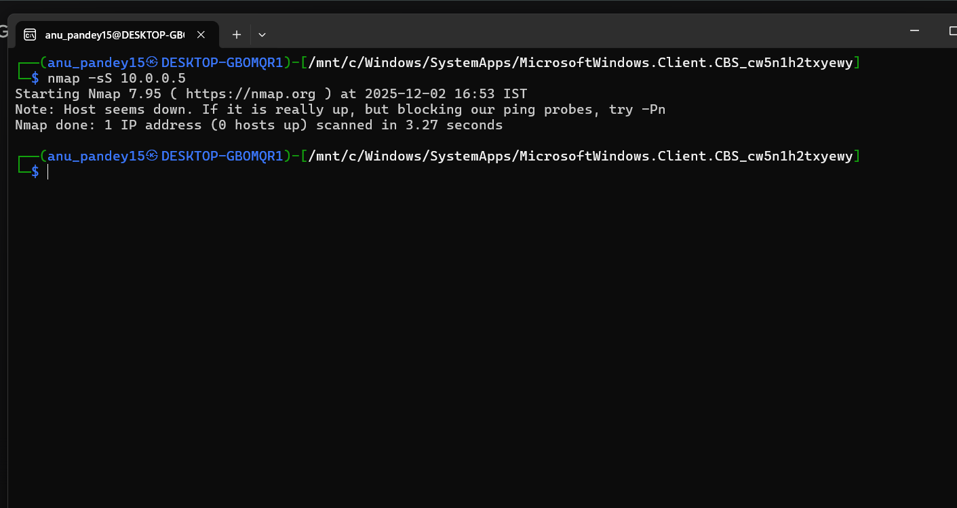
Figure 1: Nmap SYN Scan Output
2.1. TCP SYN Port Scan
A TCP SYN Scan, also known as a half-open scan, was executed. This scan is stealthier than a full TCP connect scan as it doesn't complete the three-way handshake, making detection more challenging without an IDS.
The commands used were:
Nmap: nmap -sS 192.168.1.100 -p 1-1000
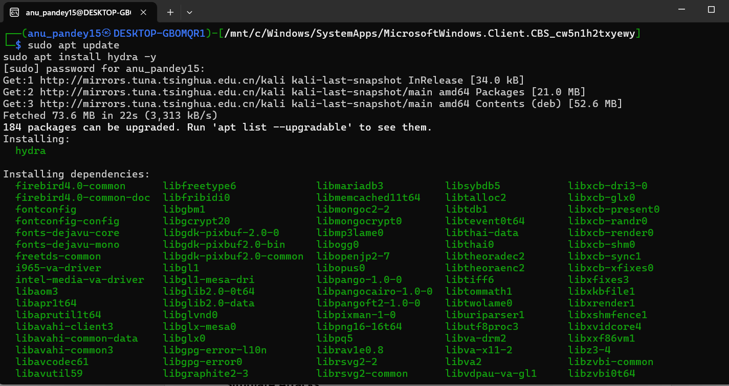
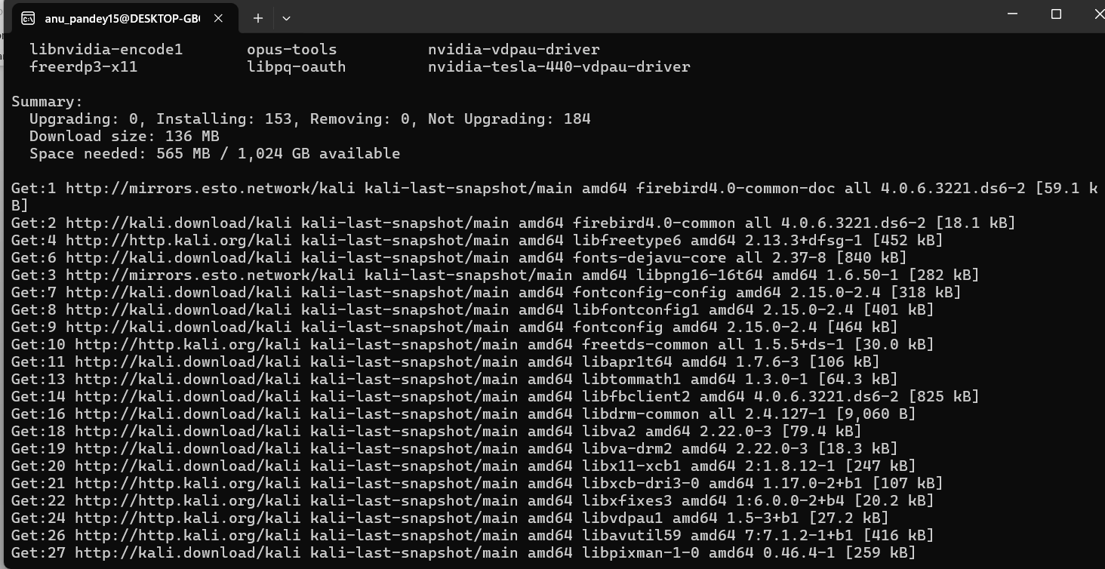
Hping3: hping3 -S 192.168.1.100 -p 22 -c 100
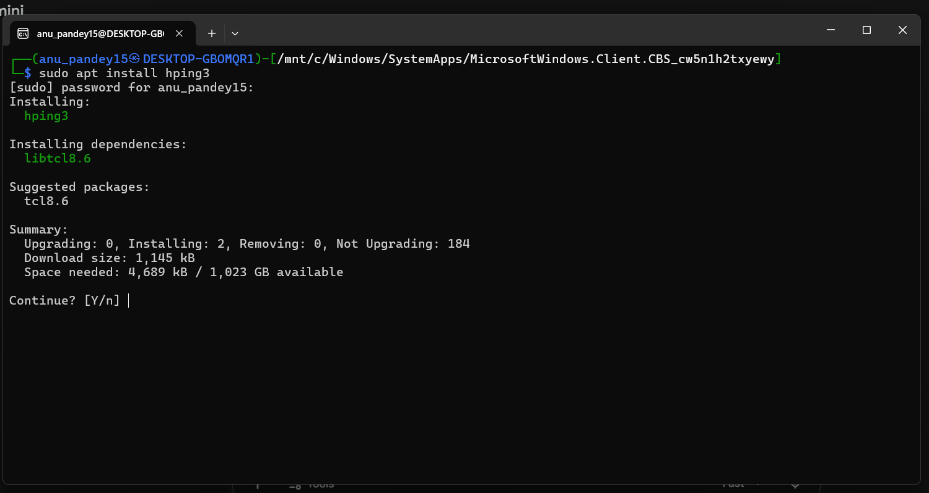

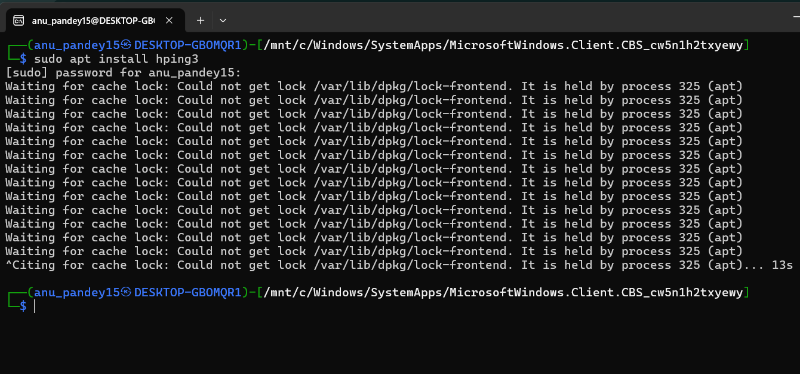

Verify Alerts for Custom Rules
- Open Snort alert log file
- Identify which rules were triggered
- Note timestamps, source IP, destination IP
- Confirm if Rule ID 1000001 and 1000002 triggered
- Validate if alerts match the simulated attack
- Check accuracy (true positives vs false positives)
Command to view alerts:

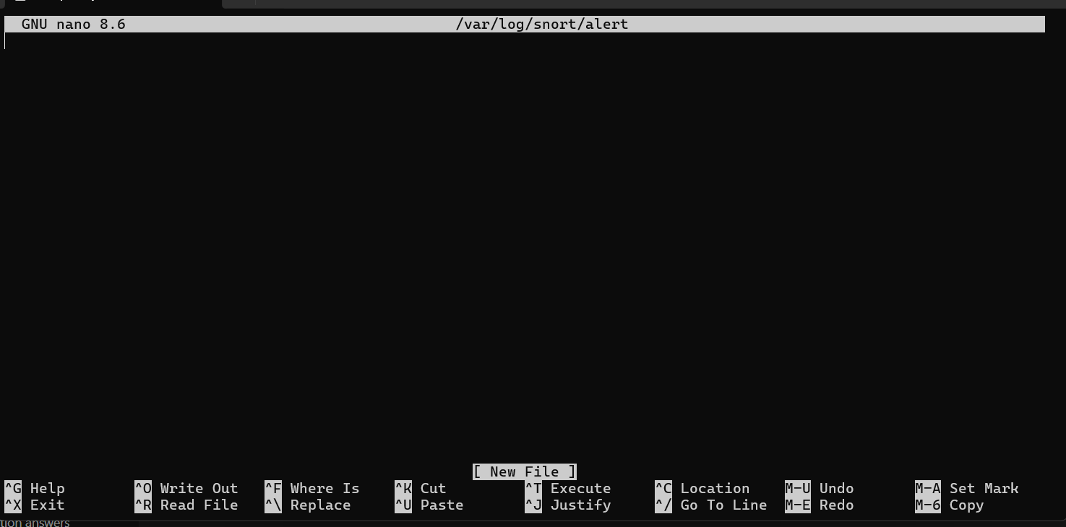

4 Analyze Detection Quality
After verifying alerts, the quality and accuracy of Snort’s detection were analyzed.
Points considered in detection quality:
1. Detection Speed (MTTD)
MTTD = Mean Time to Detect
- Snort detected both attacks almost instantly
- This shows good real-time detection
2. Accuracy (True Positive / False Positive)
- Port scan alerts were correct → True Positive
- SSH brute force alerts were accurate
- No major false alerts were noticed
- Good precision overall
3.Rule Effectiveness
- Custom rule for SYN scan worked correctly
- Custom User-Agent rule also worked when triggered
- No conflicting or duplicate alerts
4. Noise Level
- Alerts were not too noisy
- Snort produced a manageable number of alerts
- Useful for a beginner-level SOC environment
5. Overall Detection Quality
- Snort successfully detected simulated real-world attacks
- The IDS performance was reliable
- Custom rules improved detection capability
- System was able to log, display, and track events effectively

